**Walk 6 The Golden Valley**

Last walked in March 2017

**Description.** An 8 km (4.9 miles) walk along the Golden Valley, which is one of the most tranquil places in the county, a wide vale laced by lanes and tracks, dotted with hamlets and villages and bounded by the first upwelling’s of the Black Mountains. This walk requires a lot of effort as its up and down a number of steep hills.

**Start.** Peterchurch. Explorer Map OL13 Grid 345386.

**Direction from Tesco’s roundabout** (Turn milometer to zero). Take the A465 to Abergavenny. At 0.8 mile you TR onto B4348 to Clehonger 2. At 2.8 miles TL to Peterchurch. At 5.4 miles at a T-junction TR for Peterchurch. In Peterchurch, at 10.3 miles, TL down the lane beside the Boughton Arms pub and by the church. TR into car park.

**1.** **Peterchurch. *The Golden Valley is one of the most tranquil places in the county, a wide vale laced by lanes and tracks, dotted with hamlets and villages and bounded by the first upwellings of the Black Mountains and low, wooded ridges and commons. This walk starts from the capital of the valley, rising easily to the site of one of the many defensive sites in the area and offering tremendous views across rolling acres of sheep pasture and golden cornfields to distant hills and mountains. Despite its name, the Golden Valley takes its name from the Welsh ‘dwr’ – water, referring to the River Dore that has carved this delightful unspoilt vale east of the Black Mountains.*** From the car park TR and join the Herefordshire Trail. The church is on your L. Cross the river bridge and bear L then swing R ro walk along a track that traces a course past a farm to reach a minor road. TR and walk along this road, passing Hinton Hall on your R to reach the crossroads. TL, walk for about ¾ km, gradually climbing up ‘Long Lane’, passing a string of cottages and houses. You’ll pass by a house called Temple Bar (L), ‘Nurse’s Cottage’ (L), and about 150m after this and opposite a lone white house called ‘Rose Cottage’, take the finger posted stile on the L, going up steps and into **F1**. Walk straight across the pasture, heading towards an overhead power line pole to go over two wooden planks and across a couple of stiles either side of a track here at Hostley’s Farm.

**2. Hostley’s Farm.** Go ahead between the breeze block buildings and a metal gate, immediately beyond these, cross over a way marked ladder-stile on the L. Walk a few paces and TR to cross a stile into **F2**. TL, at the end of the field you cross a stile and three planks into **F3**. TR and walk along the L field edge. At the top L hand corner you cross a stile into **F4** and take time to admire the fine views across to Hatterrall Ridge, the edge of the Black Mountains. Go Half R down this field and cross a stile/gate in the bottom R hand corner, (by the corner of the woods, into **F5**. Go half L and near to the far R corner of this field you cross a wooden footbridge that goes across Trenant Brook into **F6**. As you climb the L side of this field, look for a small metal gate on your L. Go thru this gate, across a footbridge and into **F7**. TR, continue to walk up to the top R corner of this field and to Oatley Farm ahead. TR thru a metal gate and walk thru the farmyard to join the rough access loose stone track that continues on to cross over a cattle grid onto a road that’s over ½ km away.

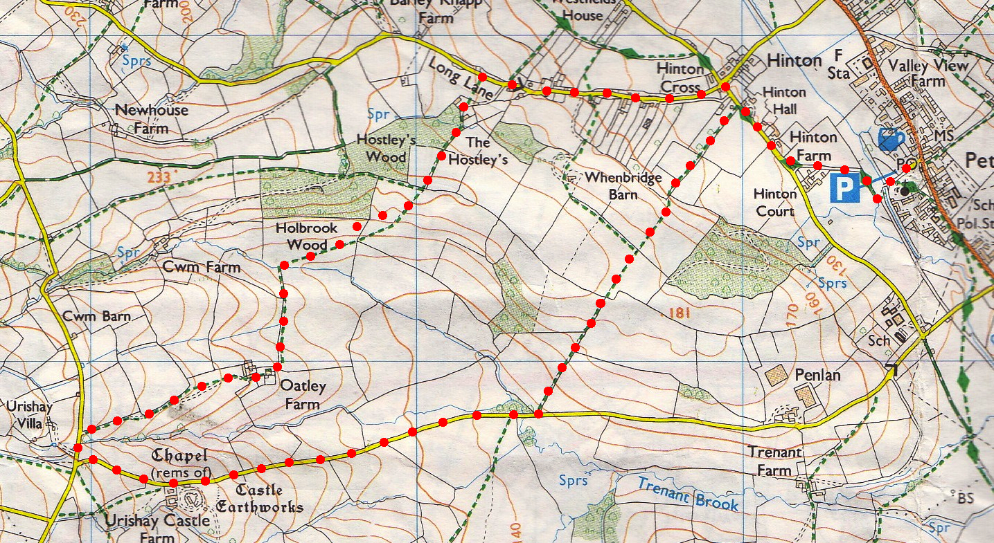**3. Road.** TL, then L again at the nearby junction and continue down this lane for 1.6 km. ***On the R you pass the gated entrance to Urishay Castle Farm (private, no access). Urishay Castle was one of the countless fortified sites built to defend against the marauding Welsh in Norman times.*** Just as the road starts to rise beyond a bridge that goes over Trenant Brook, take the way marked path, L, and go thru the L set of gates into **F8**. Walk up the R field edge and at the top R corner you cross over a slab stile into **F9**. Go across a stile in the fence ahead into **F10**. Straight across this field and over a stile into **F11**. Walk on down the pasture, just R of the centre of two pylons, to a stile beneath trees in an offset corner. Cross this stile into **F12**. TR, continue down the R side and thru a gate into **F13**. At the bottom R corner you go over a stile and along a driveway and onto a road. TR, walk along the road and fork L at the ‘No Thru Road’ to return to the church.

**2**

**1**

**3**